**Chapter 3 – EXPRESS API EVENTS FUNCTIONALITY**

**-: Content:-**

* **Introduction**
* **Create Registration.js file**
* **Create RegistrationController.js file**
* **Create ApprovalContraller.js file**
* **Create RejectionController.js file**
* **Use postman to Findout result**

**1.Introduction**

In the previous chapter we are know about the user and event part and also known about the login for a user and now we are know about the registration for and event and also approved and event using registration_id and rejection and registration using registration_id. We have create three controllers file that is RegistrationContraller, ApprovealController, RejectionController. Create and registration.js file that consists registration schema.

**2.Create RegistrationController.js file**

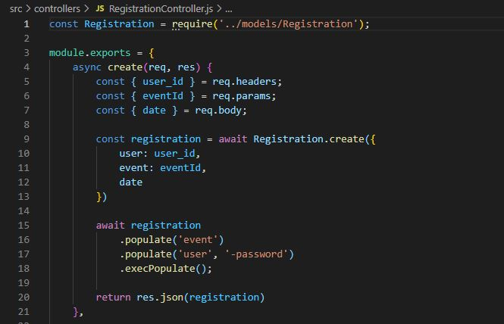

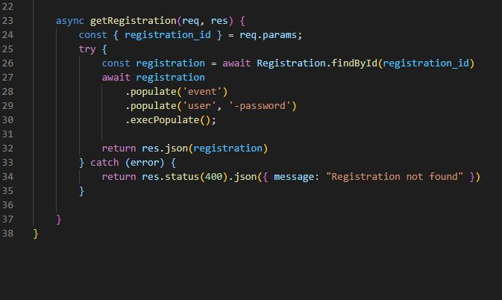

**Explanation:-** In RegistrationContraller file we use **async create()** method to create a registration id by using **user_id** or **event_id**, date . After creating the **registration_id**. We use **Getregistration** and use **FindById()** method we are Findout the particular event use by populate function.

**3.Create AppruvalController.js file**

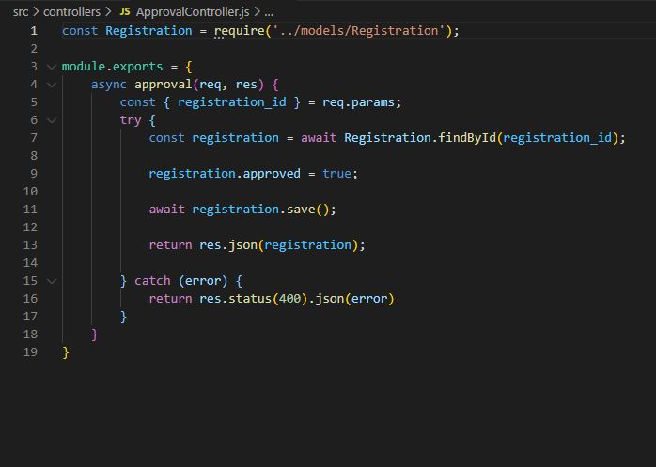

**Explanation:-** ApprovalController is a controler where we are define an event approval using some Boolean function . Use approved we Findout the registration id if the registration id is find then we match the details if the details is match then true the function .

**4.Create RejectionController.js File**

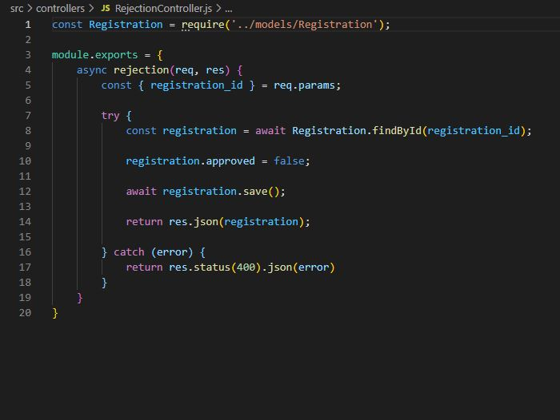

**Explanation:-** RegisctionController is a controler where we are define an event approval using some Boolean function .Use approved we Findout the registration id if the registration id is find then we match the details if the details is match then false the function .

**5.Create registration.js file**

**scr>models>registration.js**

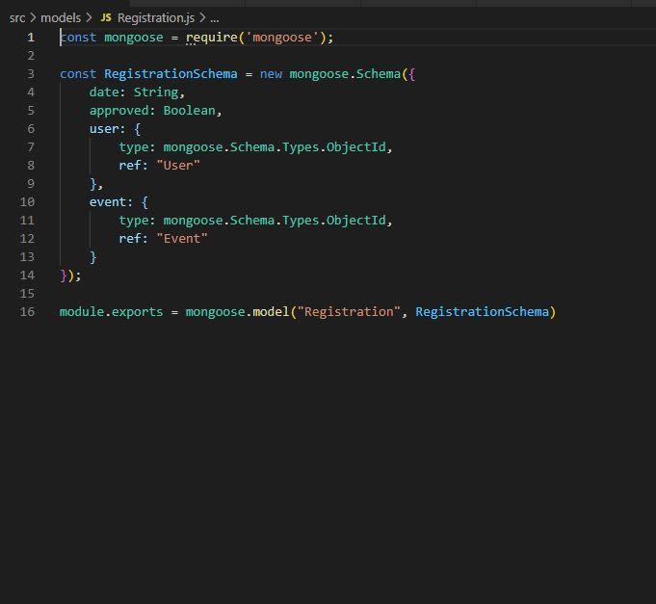

**Explanation:-** Regitration.js is define the registration schema on the registration part .Use the help of Boolean method we can approved and rejection and user and event. Help of mongoose we and interact or fetch the data from database.

**6. Create Routes.js File**

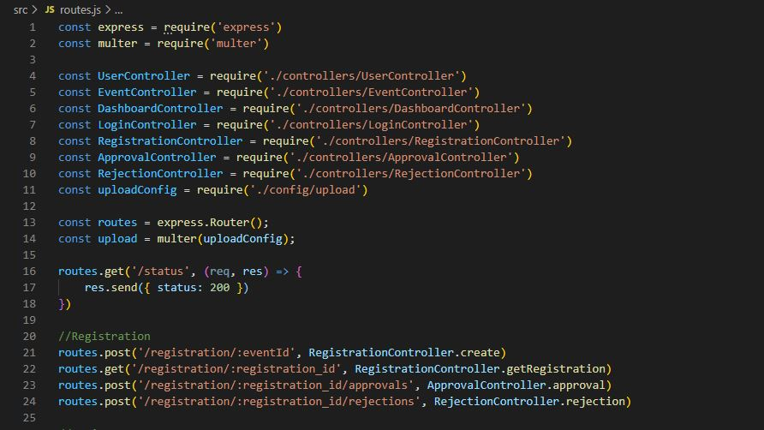

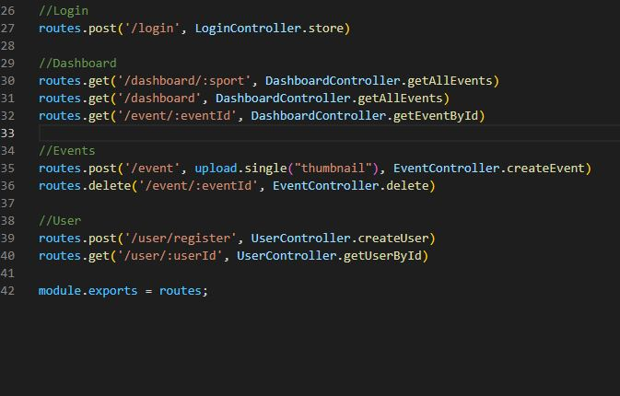

**Explanation:-** Routes.js is a file where we are connected each file and construct the method of request . Its connect the middleware file that’s help to server to Findout and gave the results properly.

**7.POSTMAN**

**7.1 Use postman for Registration**

Step 1 – For new request go to “+” icon and add a new request .

Step 2 – Select method post and put **localhost:8000/registration/event_id**

Step 3 – Select herder click on send and result is given bellow. if we gave the registration id then its show the result.

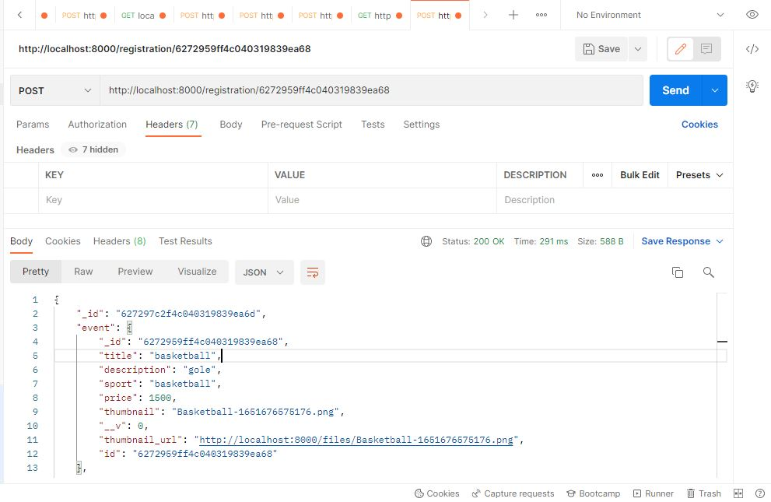

**7.2 Use postman for approval**

Step 1 – For new request go to “+” icon and add a new request .

Step2 – Select method post and put **localhost:8000/registration/registration_id/approvals**

Step 3 – send the request its gives the result against the registration id is true that’s mean that particular registration id is approved.

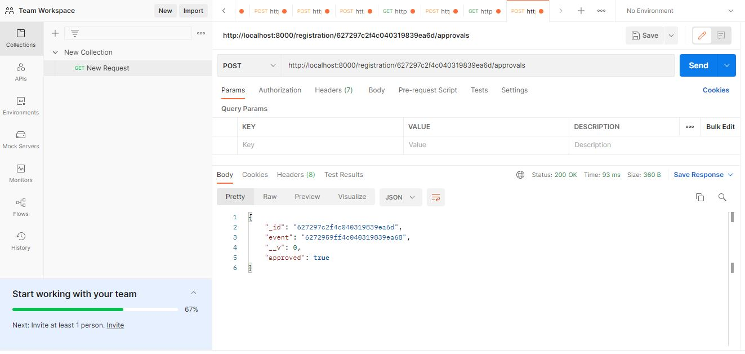

**7.3 Use postman for Rejection**

Step 1 – For new request go to “+” icon and add a new request .

Step 2 – Select method post and put localhost:8000/registration/registration_id/rejections

Step 3 – send the request its gives the result against the registration id is false that’s mean that particular registration id is rejection is done**.**

